**Integrated Science**

**Biological Science**

**Work Book**



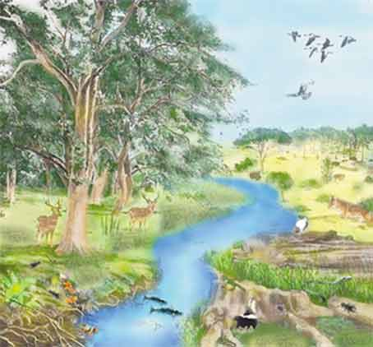

Read content and complete activities and questions as directed by your teacher on file paper in full.

Name: _____________________